Name: Dohyun Roh
Email: roh1@umbc.edu
Location of project: submitted on GL

Project Description:

General:
It is a simple javascript/html/css application that helps teachers teach kids how to tell time by reading a clock with hands. It allows teachers to add students to a list, then enables students from the list to log in to play and read time on a clock with hands. Depending on how well they do, a message is displayed at the bottom on how they are doing so far. Afterwards, teachers can access their scores (number of right, wrong, and percentage). Viewing the student data and deleting a student are both password protected.
(Default password is "tellingtime").

What everything means:

On the html, it shows a big visible clock that is meant to be read.
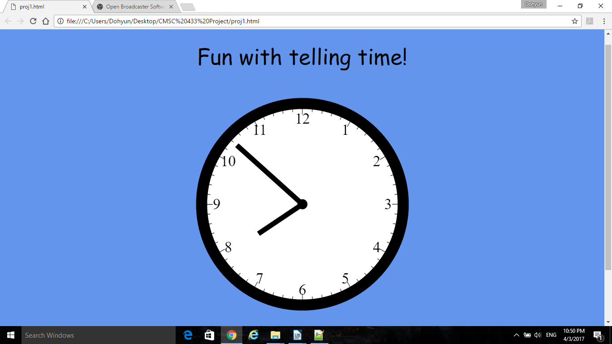
If you scroll down, you will see options for adding students, viewing studentss performance, removing students, logging in, and actually playing the game.

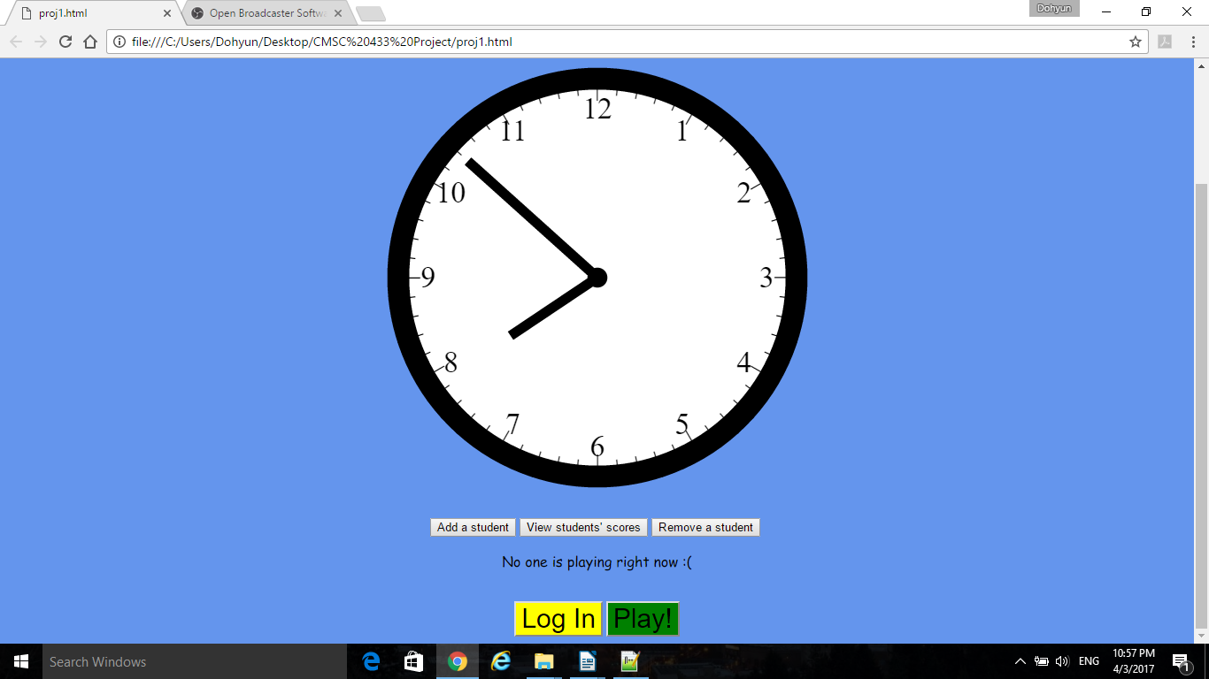
To start, either the instructor or the student can enter a student by pressing the Add a student button.
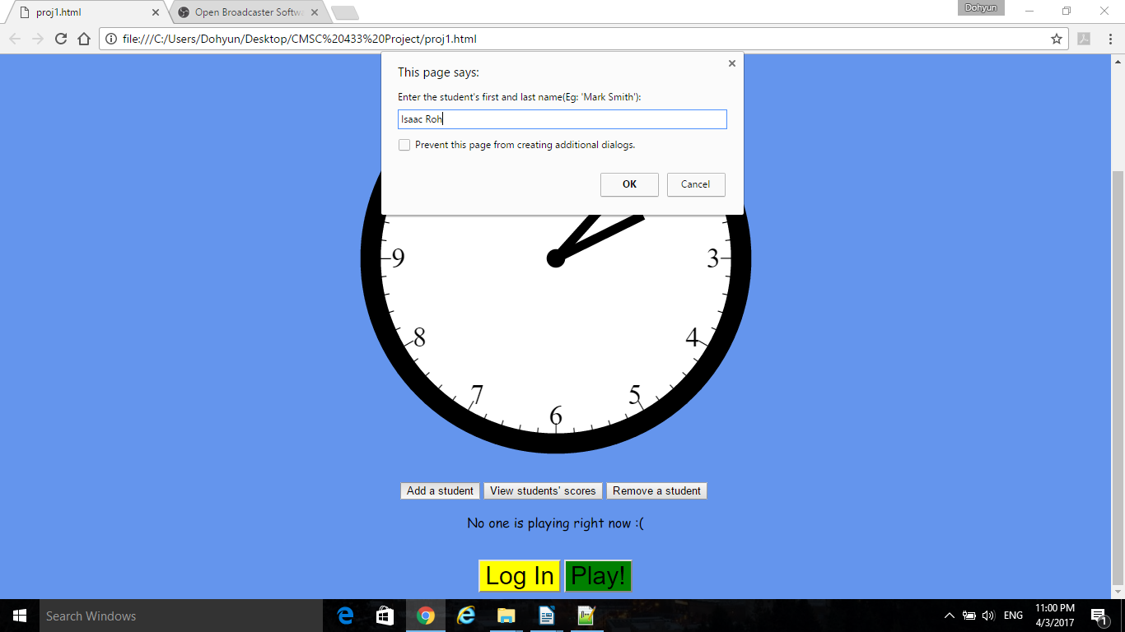
The user will be asked for a name. For this example, "Isaac Roh" was added.

Note that if the user tries to add another student with the same name, it will not add the student and
instead, ask the user to type a different name, then suggest to add the name in a similar but different manner(eg, Tyler1, Tyler2, etc).
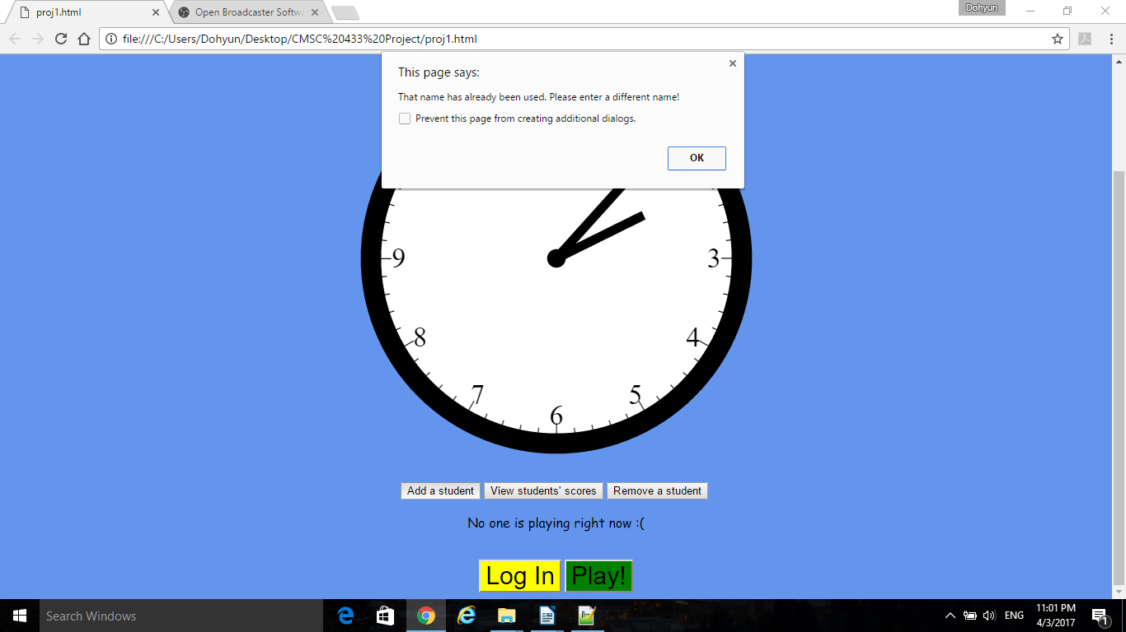

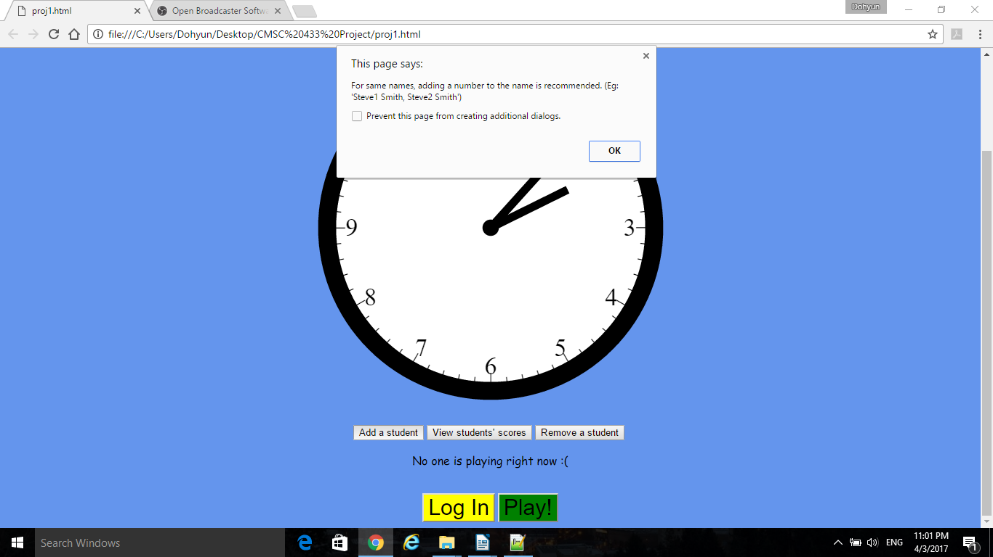

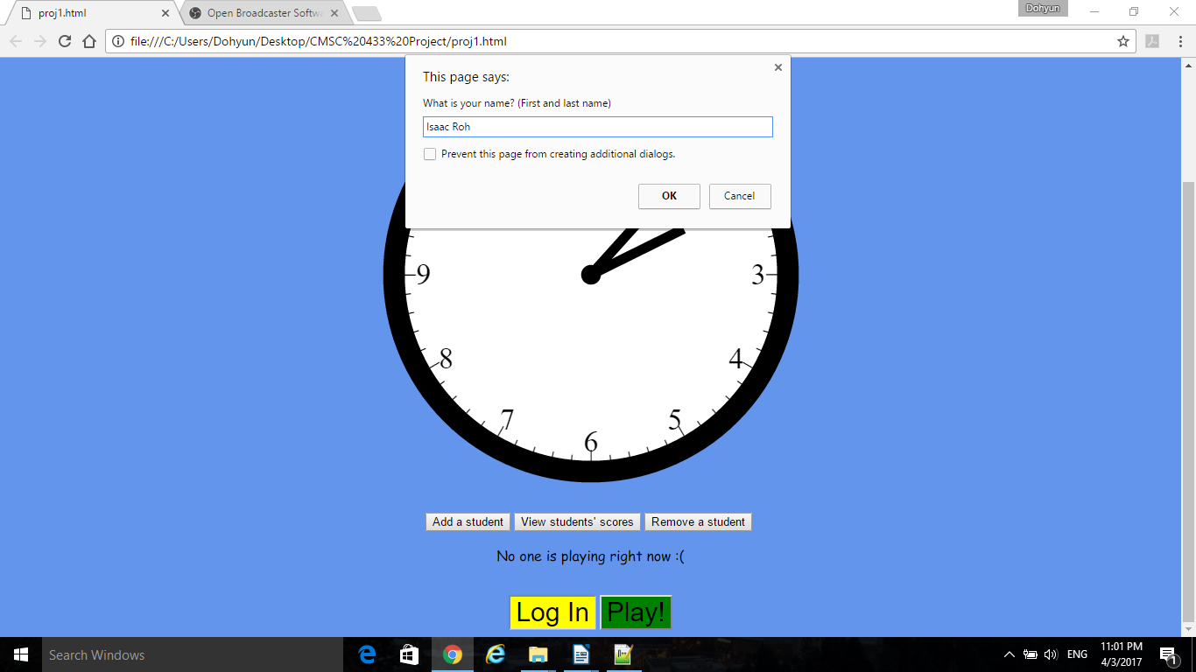
Once a student is added, the student can log in using the login button. When pressed, it asks the student for his or her name. After the student has logged in successfully, he or she can play the game now. It will also display the current student who is logged in. Note that only students that were added can access the login and play buttons.

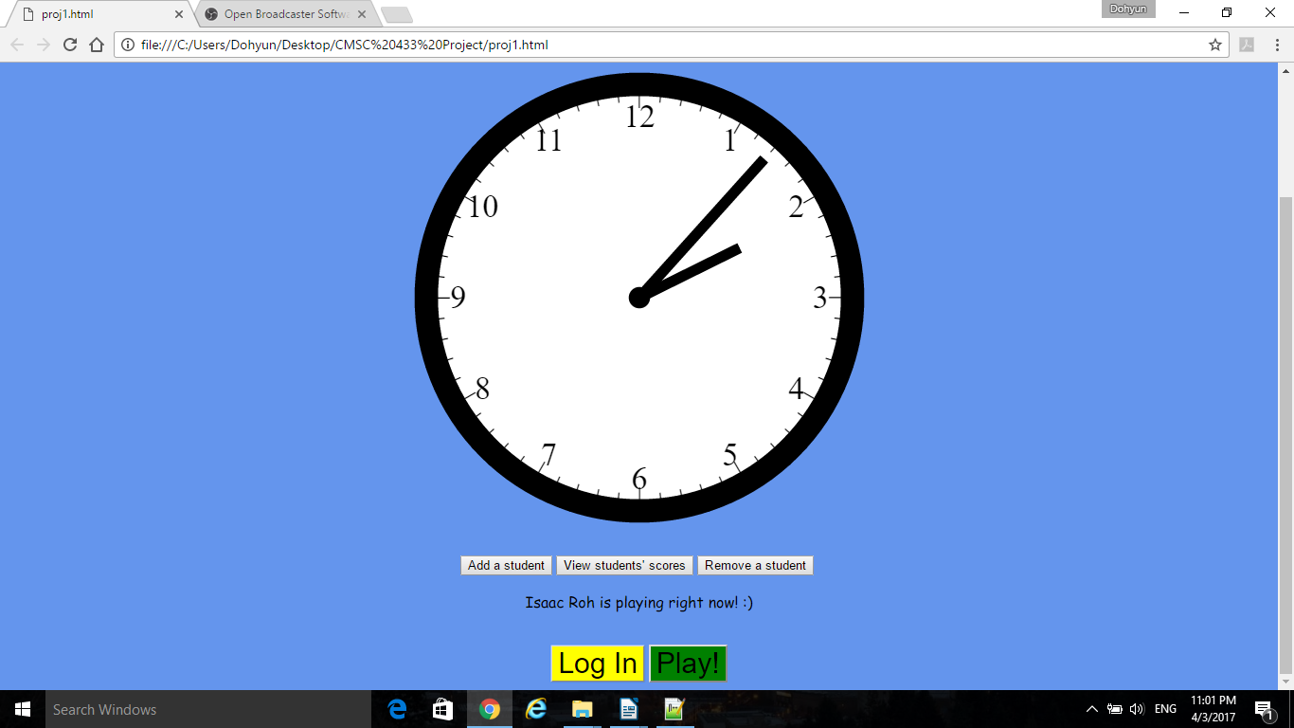
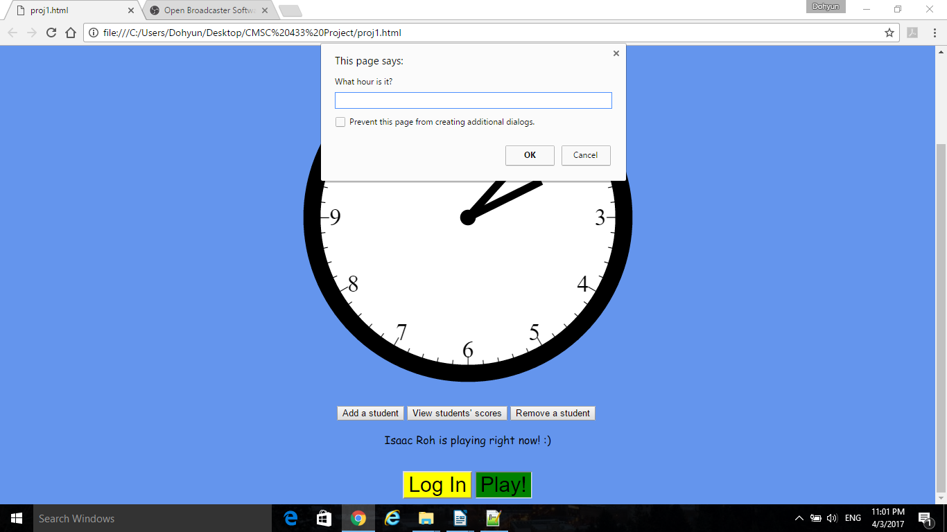
When play is pressed, the student will be asked the hour, and the time. If correct, it says "great job!"
to the student. If incorrect, it says "Wrong. Try Again!".

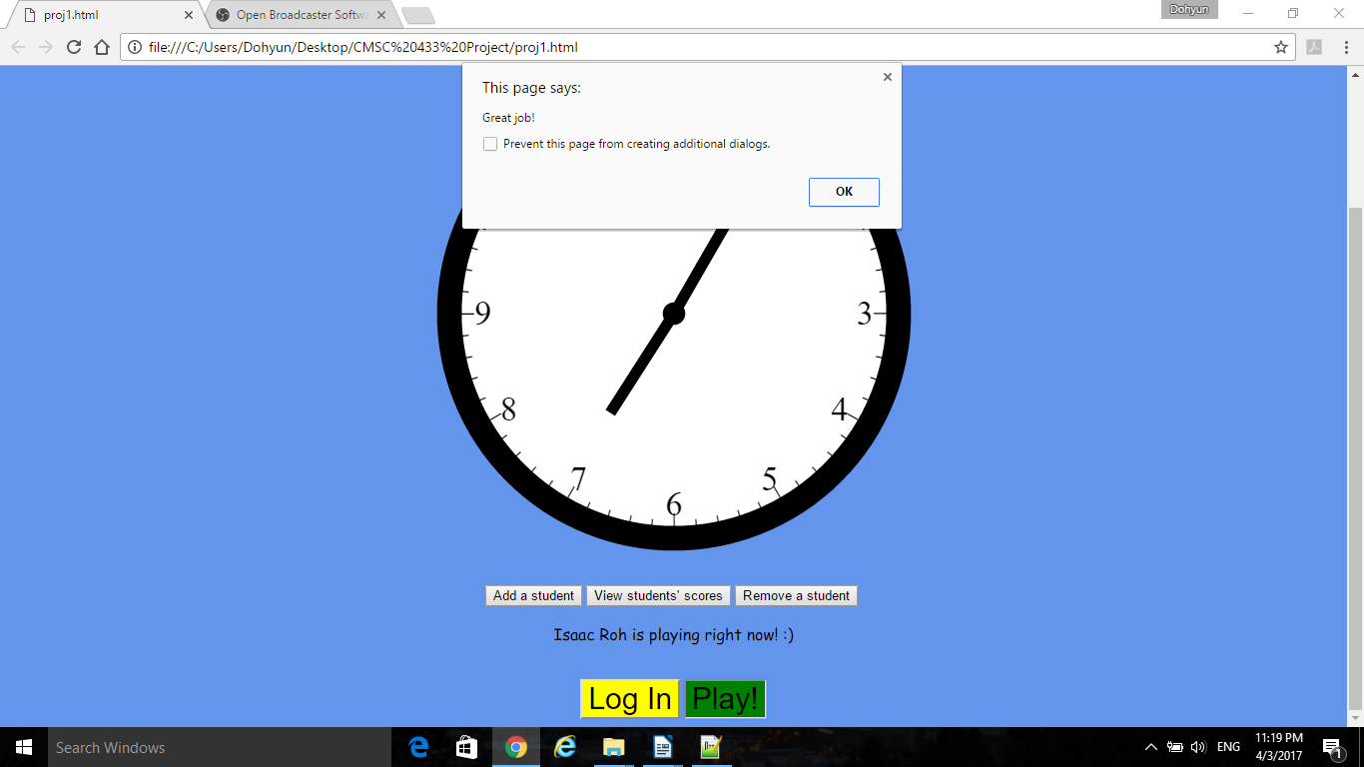

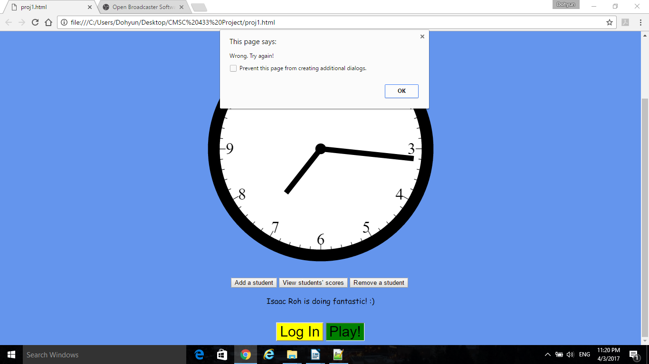
In this example, the student has gotten one wrong and one right. This is a score of 50%. The page then displays a message saying he or she needs more practice (shown below). To see what percentages show which messages, please refer to the comments in proj1.js.
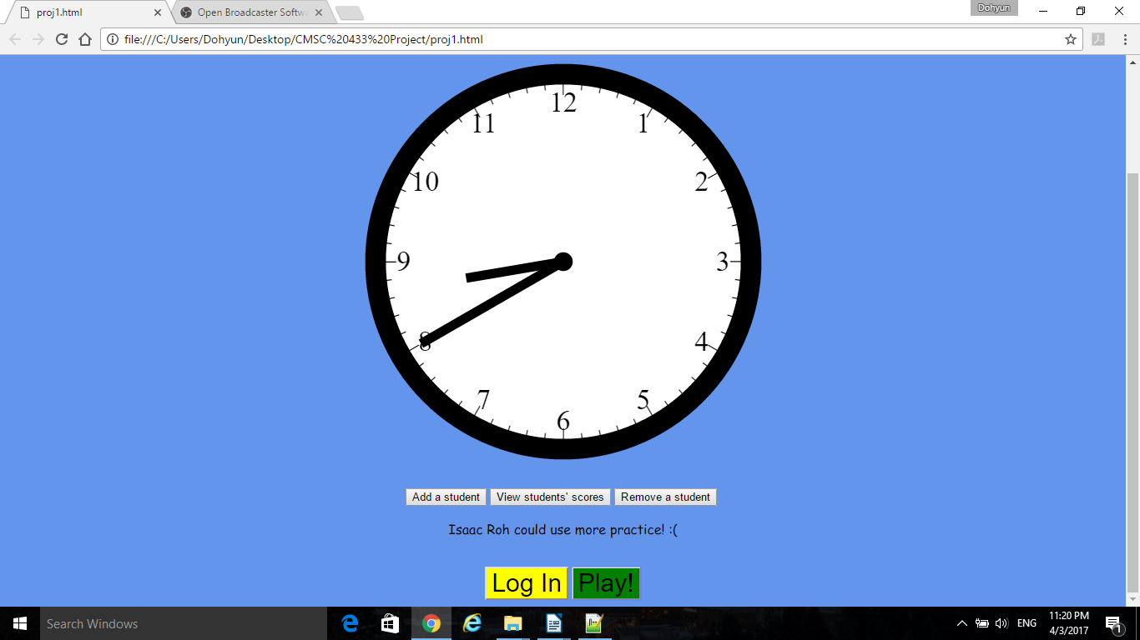

Now that there is some student data, scores can be accessed by clicking View students' scores. Upon the first click, the user will be prompted for the password (tellingtime).

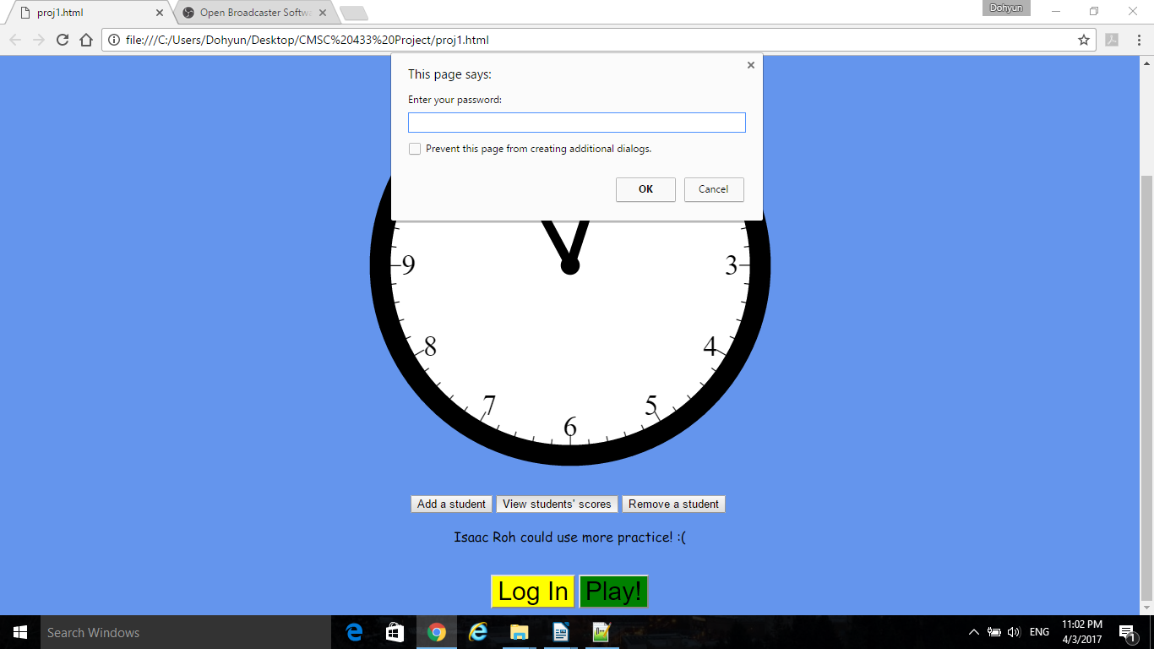
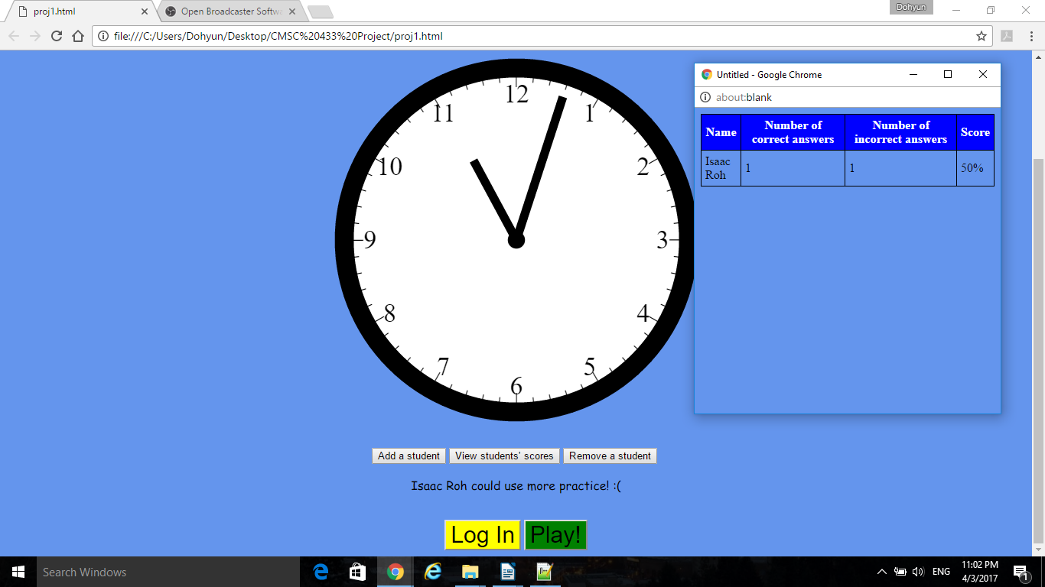
After inputting the password, a window shows up showing a table of correct answers, wrong answers, and the correct percentage of all students. In this case, Isaac Roh is our only student, with one correct and one wrong answer, giving him a score of 50%.
Since a student is already added, he can be removed as well. The insructor can clock Remove a student, which prompts the insructor for a password, just like before. After that, the page prompts the user for
a name.

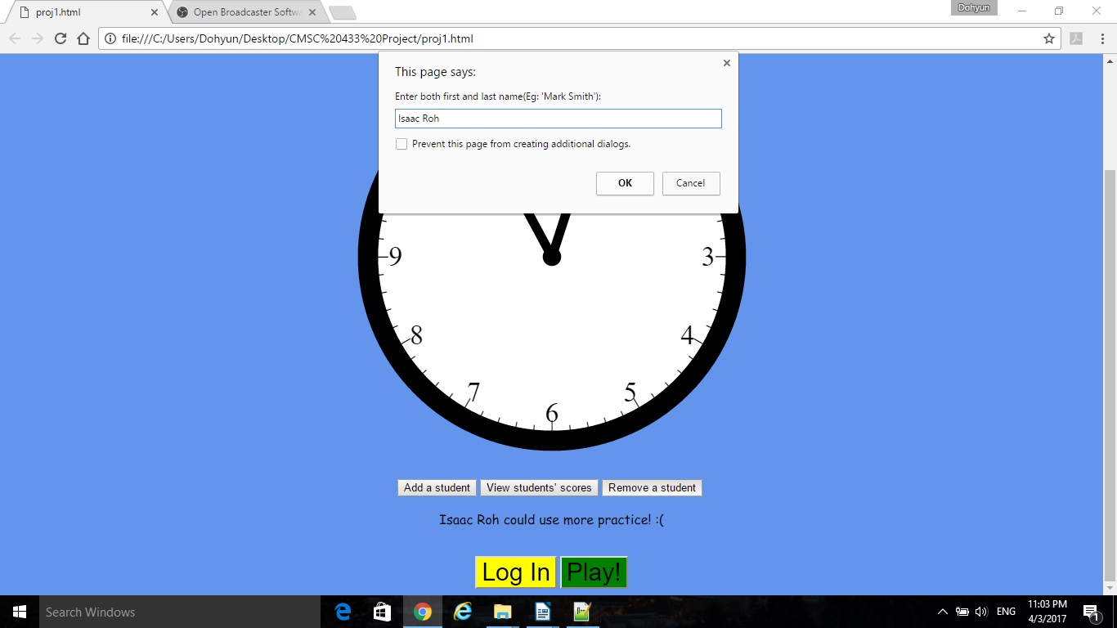
If the name matches any of the students added previously, it will remove the student from the system
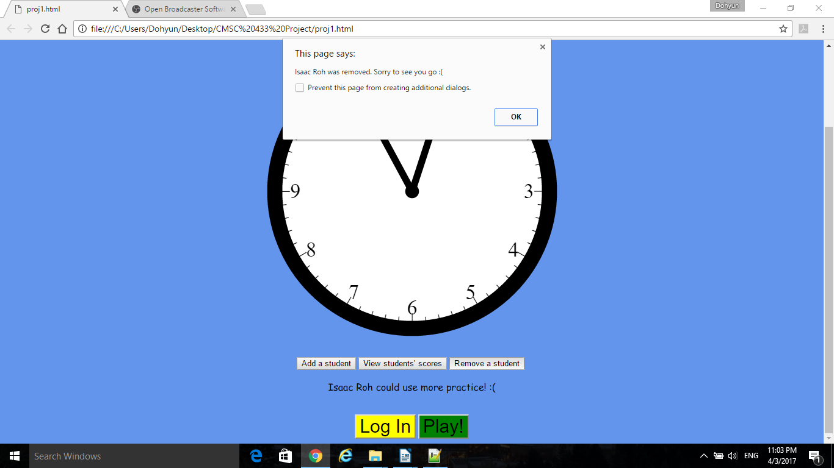
and confirm that the student is gone.

